CURRICULUM VITAE

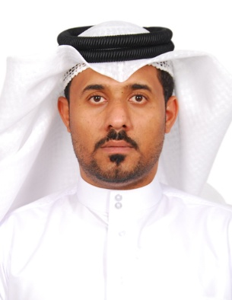

**Name: Jaafar Mohamed Jaafar abdlhussuin Ebrahim**

**Address: Hamad Town -House: 217, Road:1604 , Block:1216**

**Date of Birth: 1st May 1985**

**Mobile: 39363361**

**Marital Status:** **Married**

**E-mail:** [**Mr.Jaffar85@gmail.com**](mailto:Mr.Jaffar85@gmail.com)

**Objective .**

**Serve in a firm that enables me to use my knowledge and exchange it with others (Expertise) through my enrollment in a wide firm such as yours. Further studies to obtain a higher degree in my field and.**

**Qualification .**

* **2007 Bahrain Training Institute National Diploma in Motor Vehicle Engineering 3yesrs.**

**WorkExperience .**

* **Mister Machine B.S.C.C (Maameer Main workshop Mechanic diesel and petrol) from 2017 June to 2017 September.**
* **Working in garage from 2016 dec to may .**
* **Sayed kazem al-drazi foundation(supervisor workshop) from 2016 Qct 30to 2016 sept 12.**

* **Behbeani Brothers w.l.l. (Audi service workshop Technician) from 2007 Oct to 2016 Aug 9year and 7manth.**
* **Repair engine and gear box procedure .**
* **Repair air condition procedure.**
* **Wheel alignment procedure.**
* **Repair electrical fault basic.**
* **Air bag system procedure.**
* **car maintenance.**
* **Driver (part time morning). From to 2006 6manth.**
* **Working in garage (part time evening ). 2005 5manth .**
* **Trainee Institute NationalMotorCompany 2manth.**
* **Trainee school in Bapco 2003 1month.**

**Educational Background .**

**April2017 Auto dice inventor (sill studying ).**

**Oct2015 First Aid CPR AED in KHUH Training Center.**

**Oct 2014 2days Basic qualification level -3 in Dubai Training center.**

**Oct 2014 2day** **(DSO) Systematic fault finding in electrical systems in Dubai Training center.**

**Oct 2014 4days Communication Strategies inVictory institute.**

**June 2014 4days Basic qualification level -2 in Dubai Training center.**

**Jan 2014 One day Training course in fire fight in School of civil defense head quarters.**

**Nov2013 Basic qualification level -1 in Dubai Training center.**

**Nov 2013 4daysVehicle electrics in Dubai Training center.**

**Sept 20 13 7days Business English in Bahrain Institute.**

**Mar 2012 Air condition system in Dubai Training center.**

**Sept 2011 Service fast track qualification Dubai Training center.**

**Aug 2010 Advanced & expert Audi service workshop in Dubai Training center.**

**Mar 2010 Basics of engine management and Tester using diagnosis in Dubai Training Center.**

**Jan 2010 Basic introduction, Read drawing wiring, checking & Removal & Service Air Bag**

**Course in Dubai Training center.**

**June 2010 4days Business English in BIHR.**

**June 2010 One month General English in Modern institute.**

**2001 3years AlJabirya Technical Secondary School.**

**Languages .**

**Arabic (read – speak – write)**

**English (read –speak-write)**

**Skills .**

**I am a fast learner and am willing to work as part of team and keen to learn about new tasks required to my job, Good General Computer Skills.**

**Reference**  .

1. **Bahrain Training Institute motor vehicle department**

**Teacher Ail khudair and dr Mahindra contact: 17870666**

1. **Audi service workshop manger**

**Mr Michael Evans:36634662**

**3.Hasan Ahmed**

**Human Resource Manager**

**Tel:** [+973 1770 8171](tel:1770%208171)

**Mobile**: [+973 3967 7587](tel:3967%207587)

[Hasanahmed@mister-machine.com](mailto:rasool@mister-machine.com)